BIG BASKET CASE STUDY ANALYSIS

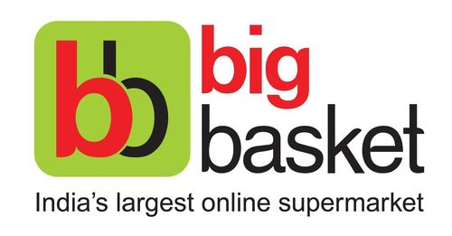

Submission Date: 16/12/2020

Name of Student (1): Nikhil Shah (B2020092)

Name of Student (2): Sam John (B2020107)

Name of Student (3): Souvik Das (B2020118)

Name of Student (4): Varsha Satpathy (B2020122)

1. **Write Case Summary**

Answer:

This case is about Big Basket where Search recommendation system has to be improved for mobile phones application and time taken for placing order also to be reduced. This will reduce consumers placing frequent orders and lest will be set as per consumer’s preference which will reduce tendency of consumers to forget things which they are supposed to purchase from the store.

1. **What is the difference in the recommender system requirements between Big basket and other e-commerce companies such as Amazon and Flipkart?**

Answer:

The quantity of product item in a single order on Big basket is much higher when compared to Amazon and Flipkart. Not only the items in the order but also the frequency of customer ordering the product is also very high. So, considering this type of order placements, for any customer placing this large number of items through smartphones is more challenging and effort consuming.

Difference between Big Basket and E-commerce companies like Amazon and Flipkart is that Big Basket lacked a “Did you forget” Section in the customer checkout division and it didn’t analyse the purchasing patterns observed previously. Amazon and Flipkart observed that purchasing patterns of their customers and accordingly they set up the relevant preferences for their customers whenever they check in and check out from their app or website. It helps in improving Customers experience and their overall Sales.

1. **What are the different types of recommender systems? Which recommender system is more appropriate for Big basket?**

Answer:

Types of Recommendation Systems are as follows:

1. Knowledge based recommendation System
2. Collaborative Filtering recommendation system
3. Content based filtering recommendation system

For Big basket, Knowledge based recommendation system is more appropriate as it will be consisting of Market Basket analysis for better set-up of preferences for customers

1. **Peform exploratory data analyses (EDA) and answer the following question:**

Answer: List Top 10 Frequent Item:

**Top 10 frequent items which are brought together**

{Other Vegetables}

{Root Vegetables}

{Beans}

{Gourd & Cucumber}

{Brinjals}

{Banana}

{Beans} => {Other Vegetables}

{Beans} => {Root Vegetables}

{Root Vegetables} => {Other Vegetables}

{Other Dals}

**Top 10 distinct frequent items bought**

{Other Vegetables}

{Root Vegetables}

{Beans}

{Gourd & Cucumber}

{Brinjals}

{Banana}

{Other Dals}

{Whole Spices}

{Organic F&V}

{Sugar}

**Min Support Set (with Reason):**

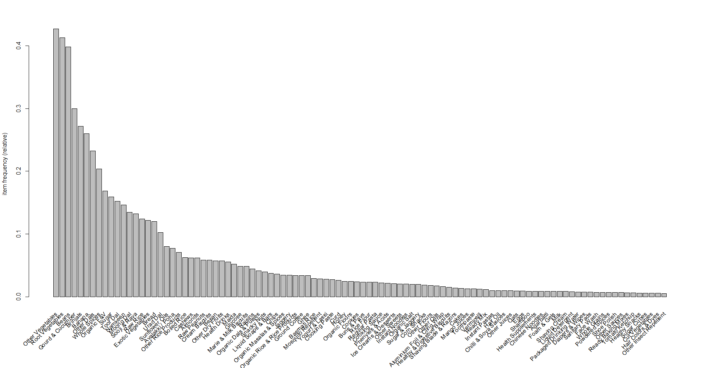

Judging from the graph, we choose 0.02 as the minimum support set, because that ensures the inclusion of maximum products in the set.

1. **Apply association rule mining using R and list top 10 unique association rule based on your finding.**

Answer:

|  |
| --- |
| **Top 10 Unique Association Rule Bases** |
| {Organic Salt} => {Sugar & Jaggery} |
| {Glucose,Sugar} => {Marie & Milk Biscuits} |
| {Beans,Glucose,Gourd & Cucumber} => {Marie & Milk Biscuits} |
| {Glucose,Organic F&V} => {Marie & Milk Biscuits} |
| {Beans,Glucose,Other Vegetables} => {Marie & Milk Biscuits} |
| {Glucose,Other Vegetables,Root Vegetables} => {Marie & Milk Biscuits} |
| {Glucose,Whole Spices} => {Marie & Milk Biscuits} |
| {Brinjals,Glucose} => {Marie & Milk Biscuits} |
| {Beans,Glucose,Root Vegetables} => {Marie & Milk Biscuits} |
| {Glucose,Other Dals} => {Marie & Milk Biscuits} |

1. Table below contains sample data from original Big Basket Data. From content based and collaborative based recommender system which one will best suit for Big Basket? Apply the recommender system suggested by you and write the similarity matrix between transaction in the box below?

|  |  |  |  |  |  |  |
| --- | --- | --- | --- | --- | --- | --- |
| Transac |  |  |  |  |  |  |
| X100 | Apple | Orange | Grapes | Plum | Green-apple | Banana |
| X200 | Orange | Green-apple | Banana |  |  |  |
| X300 | Green-apple | Banana |  |  |  |  |
| X400 | Apple | Plum |  |  |  |  |
| X500 | Apple | Plum | Green-apple | Banana |  |  |
| X600 | Orange | Grapes | Banana |  |  |  |
| X700 | Orange | Grapes | Banana |  |  |  |